SABE Board Meeting

SABE Board Meeting
Day I January 20, 2017
Atlanta, Georgia

Executive Officers:
Tia Nelis (Illinois)
Cathy Enfield (Missouri)
Chaqueta Stuckey (South Carolina)
Darren Morris (Arkansas)
Ryan Duncanwood (California) - Absent

Board Members:
Gary Rubin (New Jersey)
Carrie Varner (Minnesota)
Eric McVay (Maine)
Teresa Coleman (Georgia)
David Taylor, Jr. (North Carolina)
Vicki Wray (Colorado)
Anne Fracht (Mass)

Advisors and Allies: Juliana, Glenda, Heidi, Bill, Bernard, LaShandra, Charlotte, Tom, Richard, and Judy

Tia welcomed everyone. Teresa Coleman was identified as the participant for Georgetown University Cultural Leadership Academy for 2017. The Academy will take place in June in Santa Fe. SABE is in a (5) year partnership with Georgetown’s National Center for Cultural Competence. Teresa will represent SABE and will prepare for registration.

Members reviewed minutes. A motion made by Eric McVay. Darren Morris seconded the motion.

Tia emphasized all members need to get their states to have vote project surveys filled out. The deadline is February 28, 2017. There will be (2) free registration provided to the state that has the most surveys completed. Everyone is encouraged to complete the entire survey in order for the survey to count. This project is in place to make sure the vote experience is great. Project Vote has been working very hard. The following states are leading the way: ILLINOIS, OHIO, FLORIDA, MASS, OREGON.

SABE needs to be encouraged to re-establish relationships with the new administration. No one is going to do it for us. Do not panic. Continue to do what you do and advocate for people. We will have to fight like we never fought before. Send letters to those that are trying to keep programs in place - thank-you cards are important and must be done.
Eric McVay encouraged that everyone get to state legislators. Go to the hearings! There are national hearings that will be coming down for states to have more control. If that happens, people will have to fight harder as some states are not as strong as others in support of people with disabilities. Vicki Wray encouraged everyone to share their stories to these legislators. Fill President Trump’s head up on with our issues to let him know we are just as important as another group. We have to connect our services and get President Trump’s attention to our needs. We have to act fast, and we are not playing around. Tell anyone who will listen to write a letter. It is a must. Be creative in your thoughts and actions. Put your minds to it. Our message is “when do we save our services, NOW”.

TASH has a new self-advocate committee. TASH is preparing for 2017 Conference in Atlanta 2017. There will be a self advocacy gathering at the civil rights museum in Atlanta. Tia explained TASH’s background.

Eric asked how Tia separates her role between TASH/SABE. Tia explained she knows how to separate the two organizations. She will wear the SABE hat when voting on something for SABE and vice versa for TASH.

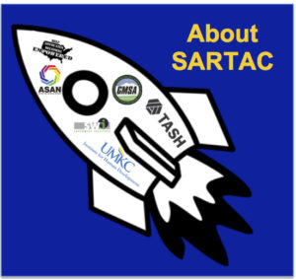
Update on SARTAC
(12) people met for the first time in Atlanta. The group got to know each other and participated in ice breakers to make this happen. The group worked to establish a plan of moving forward and establishing direction of the grant. If you want to put anything on the SARTAC website, you must follow criteria for submission. This grant will also provide seed money for any state that will be host of the national self advocacy conference. Alabama and Arkansas are looking to partner together for possible host for conference. The group will be creating and managing a website where self advocates can learn, videos, papers, partners will be evaluating, fellowships will be provided, and all of the social media options will be in place. The grant is for (5) years, and is an exciting time for SABE.

Committee Tasks
Grassroots –membership form
Legislative – write stories
Policy – write stories
PR- newsletter

Committee Reports will be done early tomorrow morning.

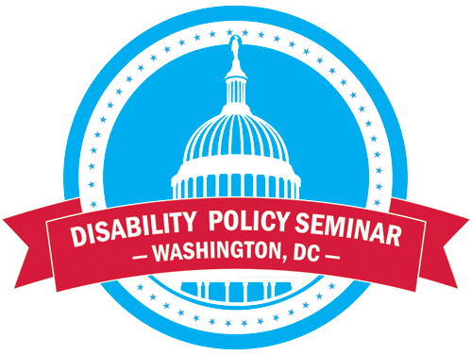
Members who will be attending the DPS will need to volunteer to work a schedule for the exhibit.

SABE board meeting March 2017, Silver Springs, Md. at the Doubletree Hotel. All rates must be the same price consistently.

Announcements:
Darren introduced his boss Tom from Disability Rights of Arkansas.

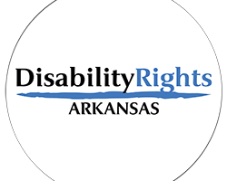

Disability Rights of Georgia, Ms. Hazel will prepare a meal on 12/21/17 to bring out the Georgia hospitality.
SABE to send a get-well card to Jason Billehaus.

Finance Committee Report (Darrel Burton and Vicki Turnage reporting via web call)

$$$$$$ Finance Report
Dates of Committee Meetings
11/30/16,12/20/16, 1/3/17, 1/12/17, 1/18/17
Committee members met by e-mail, conference call and go to meeting on dates listed.
Attending meetings and or responding in E-mail conversations were Ryan Duncanwood, Treasurer; Teresa Moore Program Director for Project Vote and SARTAC, Juliana Huerena Project Vote, Vicki Hicks Turnage, SARTAC: Darrell Burton, SABE.
Not participating: Joannie Schiele
The committee completed the following activities:
• Set up process of on-going review of SARTAC and Project Vote expenses
• Reviewed bank statements from October 2016-December, 2016
• Approved the initiation of the audit for 2016
• Followed up on payment of invoices
• Reviewed financial report for all grants
• Reviewed and approved Project Vote’s request to offer 2 registrations for 2018 conference to state that completed the most project vote surveys
Income expected:
• SABE received a $10,000 donation from Public Consulting Group from Boston
• Finalized letter of agreement with U of Minnesota for the $10,000 for self- advocacy on line
• Invoice pending to University of Mass. for $10,000
Pending actions needed:
• Transfer of incorporation- Darrell
• Thank you note for Public Consulting Group-Darrell

This committee meets every Tuesday. Eric McVay questioned how often audits are conducted regarding SABE finances.
A finance report was made by Eric McVay accepting the report. Gary Rubin seconded the motion. The board voted unanimously to approve the report.

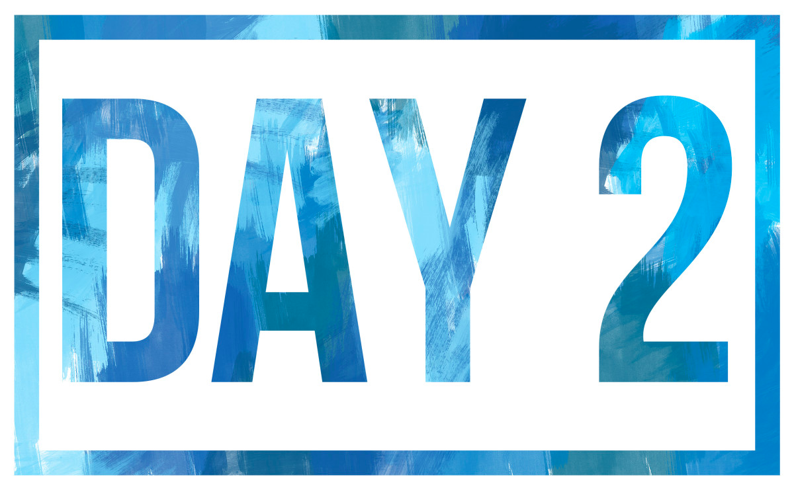

January 21, 2017

Tia briefed members on completing surveys. Other states are being encouraged to participant in distance training. States are encouraged to participate and start other projects after completing the project. When you do the survey, remind people to submit or the survey will not be complete.

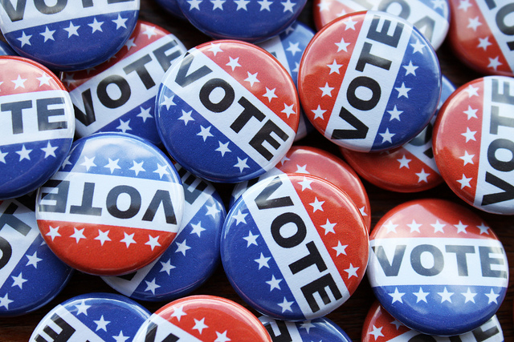
Get involved with Protection and Advocacy. Nancy Ward has moved on from the project. Anne Fracht is now participating with the vote project.

Make sure that when you commit to any project for SABE you have the time to work on the project.

Cathy Enfield led the remainder of the meeting by asking for grant reports.

Siblings Report provided by Eric McVay
See attached report
Cathy shared that she has been doing workshops at conference to unify families and siblings to be more effective. SABE will talk with Katie Arnold regarding the partnership with SABE and the Sibling Network.

Coleman Institute
SABE to ask Shea Tenis to come and speak at their Summer Board Meeting.
The annual conference will be November 2, 2017. It will have a focus on technology.
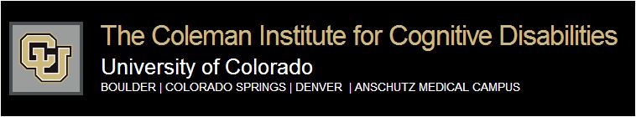

Disability Policy Seminar
A confirmation of all participating was secured.

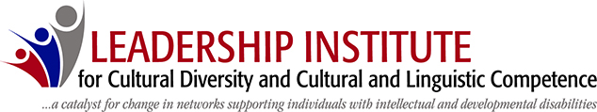

Georgetown University
Vicki Wray talked about the importance of stories and finding out about the background of families. The Georgetown project helps with bringing out leadership and helping one gain confidence. You learn so much about other people. Information was also shared about the coaching calls. Vivian Jackson is the main coach for Vicki. Culture is everything that has happened in your family that makes you who you are. It is about talking about culture in your family and sharing how we learn from each other.
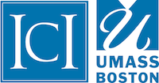

RRTC Employment Project: provided by Eric McVay
Working on white paper with a focus on Employment First. Members will participate on the state of the science conference. Members are planning to present at conference, webinars and DC to support efforts for state of the science conference. RRTC will do some things at the policy seminar.

Grassroots provided by Anne Fracht
Members have official state assignments
Darren Morris (Alabama, Arkansas, Kansas, Missouri, Illinois, Ohio,
Indiana, Nebraska)
Teresa Coleman (Georgia, Mississippi, Louisiana, Oklahoma,
Pennsylvania, Delaware, Utah, Idaho, Iowa)
Anne Fracht (Mass., New York, Connecticut, Rhode Island, Maine,
New Hampshire, Vermont, New Jersey)
Chaqueta Stuckey (South Carolina, Texas, North Dakota,
South Dakota, Minnesota, Colorado, New Mexico
Arizona, District of Columbia)
David Taylor, Jr. (North Carolina, Tennessee, Kentucky,
West Virginia, Virginia, Maryland, Florida,
International Community
Jason Billenhaus (California, Wyoming, Nevada, Montana,
Washington, Oregon, Hawaii, Alaska, Wisconsin

All members will enforce the recruitment and membership. Make contact for people to go online to complete registration form. The plan is to utilize, email, local/state self advocacy organizations.

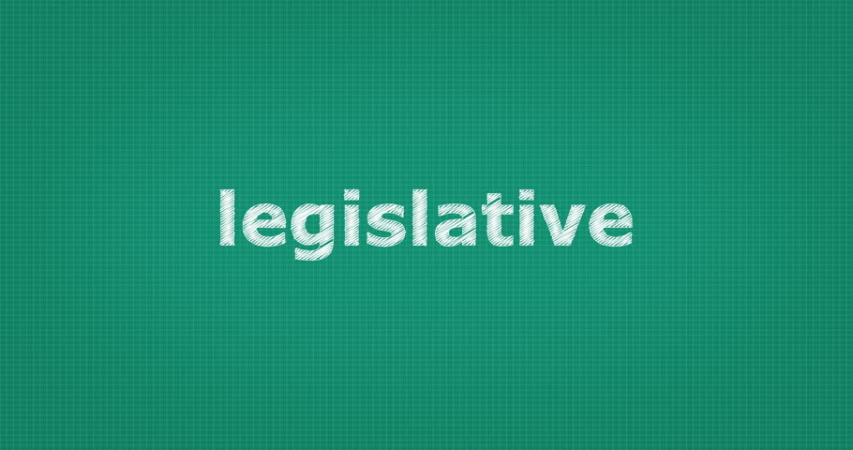

Legislative Report by Cathy Enfield
- Cathy shared a sample letter in communicating to Legislators. The letter will be on the website. Members were also informed to share the following website: whoismyrepresentative.com to support aggressive communication to legislatures. Be sure to talk to the local representatives. Get to know them.

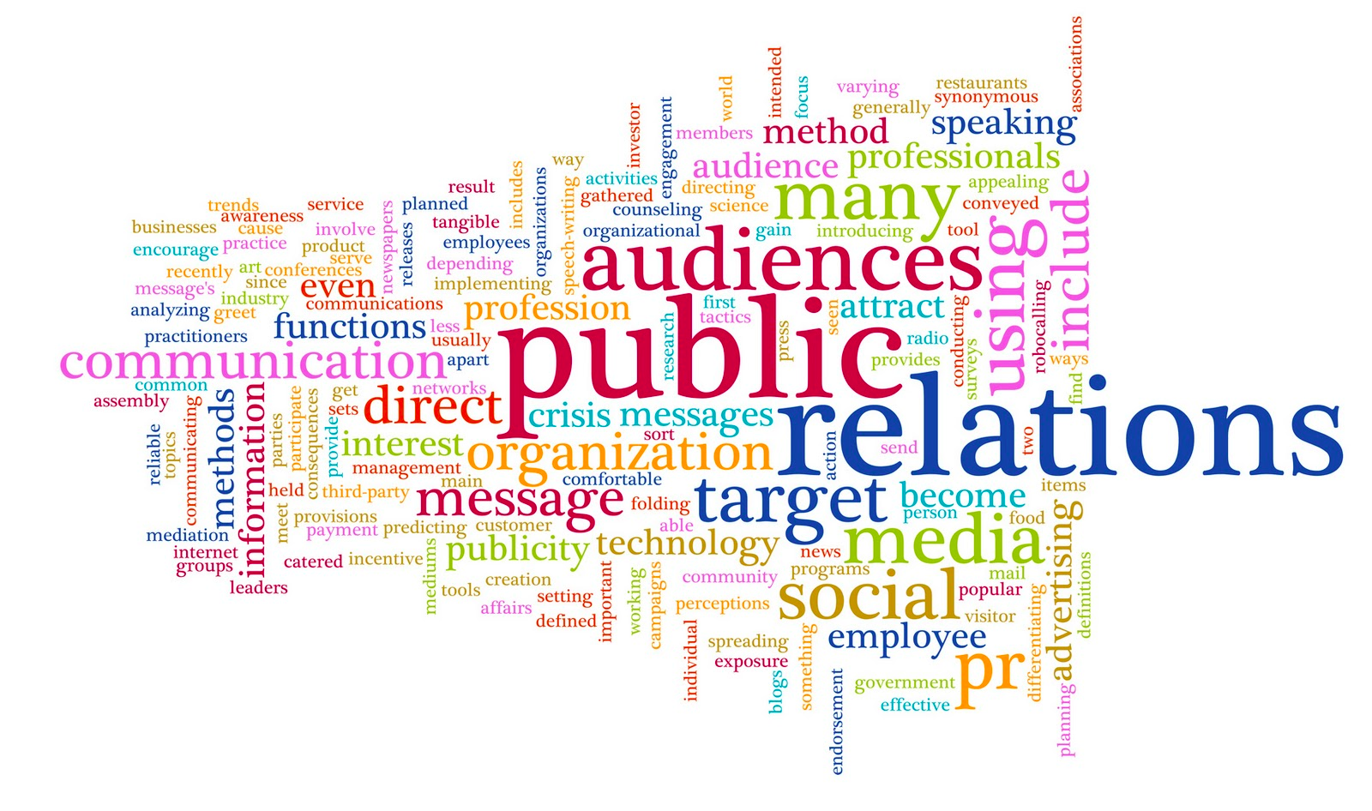

PR Report by Carrie Varner
The Spring Newsletter will come out during DPS. Members encouraged to get stories coming in to support the publishing of the newsletter. Spotlight Self Advocate, President’s Message, Darren’s constitution letter, Projects, Understanding ACA for people with disabilities, SARTAC, conference quotes, progress report on grants, and stories.

Policy Report: by Gary Rubin
The committee introduced confidentiality agreement. It is important for members to understand what is being discussed in the meeting, stays in the meeting. The group placed emphasis on Robert Rules of Order. The committee reminded members to be respectful when someone is talking. Listen to each other respectfully.

Announcements
David shared a possible fundraiser, wristbands sold for $1.00. Determine how much it would be and have a budget. Join sabe SABEUSA.org

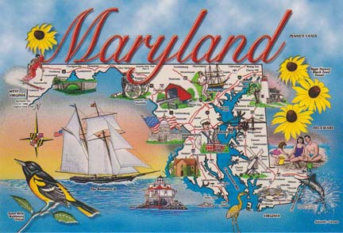

Spring SABE Board Meeting
Silver Spring, Md.
March 17-18, 2017 – Board Meeting
Summer Board Meeting
Denver, Colorado
June 8-10, 2017

Fall Board Meeting
Little Rock, Arkansas
September 28-30, 2017

Meeting adjourned.

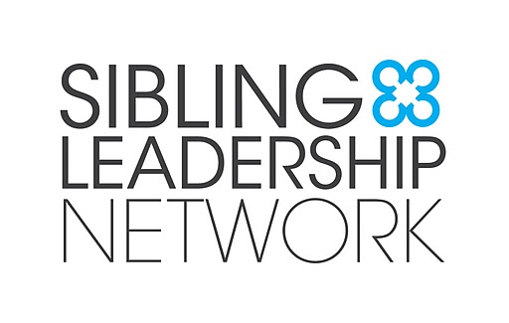
To: Self Advocates Becoming Empowered
From: Eric McVay
Re: Sibling Leadership Network Update
January 2016

As the SABE representative on the SLN Board, here is my update to the SABE Board about the Sibling Leadership Network (SLN). Please feel free to be in touch if you have any questions or need more information: ericdonald240@gmail.com.

Funding:
- The SLN received a corporate donation from the Public Consulting Group at the same time that SABE and P2P received a donation from this organization – each for $10,000! The announcement is here: http://www.publicconsultinggroup.com/news/post/pcg-announces-final-30-for-30-grants
  - Katie Arnold, SLN’s Executive Director, would like to approach this organization in the future with a representative from SABE and P2P to request additional funding for all 3 of our organizations to work together more.
  - One idea for possible funding is related to what we have been calling The Triad Perspective (3 perspectives of self-advocates, siblings, and parents) where we have been talking about how our 3 organizations play an important role in providing peer support as well as creating ways for more cross-collaboration and learning across our groups.

Grants:
- The SLN currently has a few exciting grant projects, including the following:
  - NY DD Council funded Cornell University in partnership with SLN and our sibling chapter in NY, sibsNY. We are creating SiblingResources.org, a website with resources and information for adult siblings as well as provider organizations with supports for siblings. Check it out at SiblingResources.org.
  - The Family Support Research and Training Center (FSRTC) grant does a lot of research related to supporting families. We created some great videos of self-advocates sharing what they think about family support. (Thank you again to SABE members who participated in these videos). We are also looking at ways to create Sib2Sib mentoring.
  - The NC DD Council grant is to develop a sibling chapter in NC with First in Families of NC and SLN. Their first statewide sibling conference will be March 25, 2017.

Conference:
- The National SLN Conference will be June 24-25, 2017 in Hartford, CT. We are again doing our conference in conjunction with the American Association of Intellectual and Developmental Disabilities (AAIDD).
- Funding will be used for Eric to attend the conference as our SABE representative.
- This year we will be celebrating our 10 year anniversary as an organization!
- Please feel free to share the Save-the-Date with people you know. It is on the conference webpage at: http://siblingleadership.org/2017-sln-conference/

