
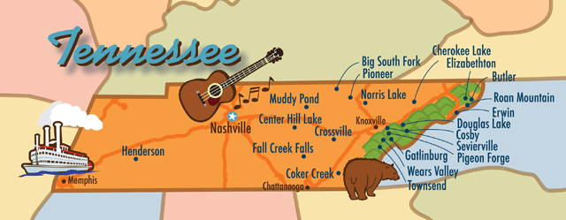
Self-Advocates Becoming Empowered Board Meeting
Nashville, Tennessee, January 2014

Friday, January 10, 2014

SABE National Board members:

President: Bryon Murray, region 3, Utah
Vice President: Cathy Enfield, region 4, Missouri
Secretary: Betty Williams, region 5, Indiana (on by conference call)
Treasurer: Ryan Duncanwood, region 2, California
Sargent of Arms: region 6, Chaqueta Stuckey, South Carolina
Jason Billehus, region 1, Montana
Amira Rasheed, region 3, New Mexico
Bill Story, region 4, Kansas
Mike Grengs, region 4, South Dakota
Carrie Varner, region 5, Minnesota
Diana Mairose, region 5, Ohio
Tia Nelis, region 5, Illinois
Bernard Baker, region 6, Georgia
Darren Morris, region 6, Alabama
David Taylor, region 6, North Carolina
Max Barrow, region 8, Vermont
Clint Perrin, region 8, New York
Ann Frecht, region 8, Massachusetts
Eric McVay, region 8, Maine
Eric Treat, region 9, Arkansas

Ally/Supporters: Juliana Huerena, Leanne Roth, Glenda H-Singletary, Vicki Turnage, Karen Topper, Essie Pederson, , Teresa Moore, Richard Enfield, Darlene Martin, and Nancy Ward

Special guest self-advocates/allies joined at different times throughout the meeting.

Meeting called to order by President Bryan Murray. All board members asked to introduce themselves and roll call taken.

The Board reviewed the minutes from October 2013. Eric Treat made a motion to accept. Motion seconded by Jason Billehaus. Motioned passed to accept minutes.

President's Report:
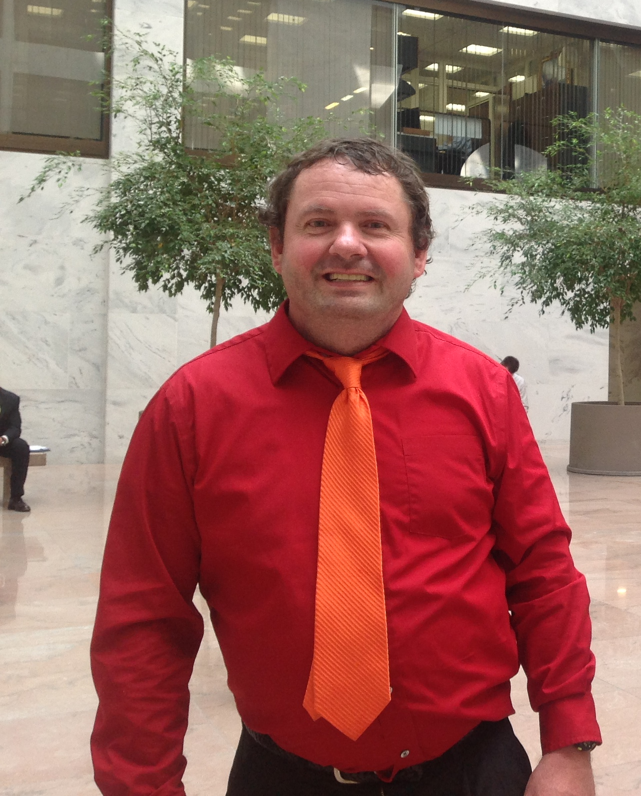
There have been a couple of attempts to get Troy on the phone to discuss status on the marriage penalty. Stories have been forwarded by: Bernard, Amira, Nancy Jason, “Q”, Diana, and Ryan have written, but not forwarded. Bryan explained what the marriage penalty is and questioned members on why stories are not be submitted. A good discussion from members was shared.

Action: Stories to be forwarded to Bryan and Glenda's email: ghsingletary@fcdsn.org

Members were encouraged to gather stories from other areas. The bottom line is if you choose to live with someone or get married, your benefits should not be cut. Topper clarified that SS retirement benefits are only against people with disabilities. Retirement does not look at the income. However, the penalty is with people with disabilities who are on SSI which is means tested. It is income based. If you are unemployed, your benefits may also be affected. A suggestion was made to consider using the stories received for poster image.

Business Plan Review and Updated for Outcomes
The business plan is moving forward. There is concern about members getting emails and communicating better. Perhaps a follow up call is necessary to make sure communication is there. The business plan was read by Juliana. The objectives and goals reviewed.

Goal 1:
Objective (Obj) #1 - accomplished.
Obj #2 - possibly $2,000/month to rent. More work needed; is there a possibility to partner with another organization on space as well as increasing meetings in Washington, DC until this is accomplished. Another suggestion is to decide on what our supports are, and what we need as space to other allies. Richard reported NDRN had some space a couple of years ago. Tia suggested that putting these request in writing and going to these organizations for negotiations. Max emphasized staying in contact with the "big shots" in Washington. The Academy committee has not met to date, but will meet very soon.
Obj # 3 - ongoing,
Obj #4 - not accomplished on 3 year start up plan,
Obj #5 - possibly contract with fundraiser; not accomplished (Tia has a contact that may be interested in fundraising).
Amira suggested that a training be developed or speaking engagement as to charge businesses on topices like: understanding of ADA for compliance with hotels, airlines for example. Mike suggested selling t-shirts at the conference. Vicki suggested crafting an email with needs for fundraising. Obj # 6, is ongoing.

Goal 2
Obj #1 - OCU grant, accomplished,
Obj. #2 not accomplished,
Obj. #3 ongoing, not accomplished,
Obj. #4 ongoing, not accomplished,
Obj. #5 ongoing, not accomplished

Goal 3 - Obj. #1 ongoing,
Obj. #2 ongoing (5 stories published in newsletter on closing institutions and webinars on living/closing institutions,
Obj. #3 ongoing,
Obj. #4 accomplished but need approval for support CPRD t-shirt sale,
Obj. #5 - accomplished
Obj. #6 on going,
Obj. #7 accomplished

Goal 4 - Obj. #1 accomplished/ongoing
Obj. #2 accomplished,
Obj. # 3 - accomplished/ongoing.
The business plan review completed.

Break given at 11:00 am; reconvened at 11:10 am.

Project Reports:
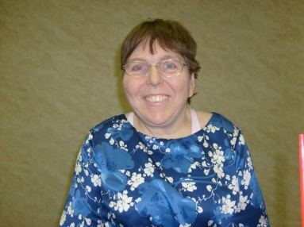
Project Vote
Nancy reported Project Vote will distribute information for review then submit document electronically summarizing report. The report summary will be in minutes. Comments on webinars need to be given to Teresa for input.

Autism Now
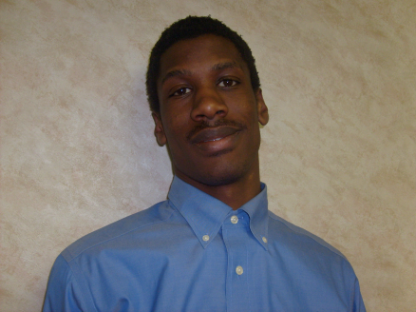
Report by Max and Topper: Accomplishments have been with forums and video blogs. Success stories will be added on closing institutions and moving in the community. Several webinars are being developed. SABE members identified to help out. See attached Autism Now. Members encouraged to go to Autism Now website. A video shared on Tips for Healthcare Professionals. Tips from the video shared to make communication better with physicians.This video provides general education on communicating and respecting people with intellectual disabilities.

OCSS – Our Community Standing Strong
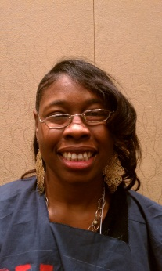
Chaqueta and Vicki reported on OCSS. Progress is being accomplished. In phase one of the work plan, demographic and state needs surveys are in action. There are some states struggling to get partners understanding. The good news is that there are some partners coming to face to face meeting on Jan. 11-12, 2014 in Nashville. Survey monkey is calculating the results of the surveys. Only one state not on tap to receive funds from first phase of expected responsibilities.

Presence in Washington (special)
Bryan, Essie and Vicki provided a special discussion on presence in Washington, DC. We must have a face there!! We need to make financial request from some of the following: ANCHOR, APSI,TASH,NDRN, P&A, DD COUNCILS, AUCD, UCEDD'S, NAACP, GOVERNOR'S COUNCIL, SEIU, ACLU, HRC, CITY OF DC, MAYOR'S ASSOCIATION, HUMAN RIGHTS INTERNATIONAL, ETC.

Bryan and Cathy will do an email blitz to all of these groups. Bryan detailed plan for ideas on responsibilities of the executive director position: fundraising, making decisions, public awareness liaison. This person will work for 20 hours per month. It may take $7,500 to get started. Eric M. stated that the person identified should be a self-advocate. Bernard said, "let's do it." Bryan is making a promise that is will happen. All members encouraged to go out and speak to DD Council, state groups, and others to give money to SABE. All members pledging to commit to DC presence.


Meeting adjourned. Committee meetings to meet at 1:45 pm


12:15 pm AIDD Grant members attended Skype call with other grantees.
ASAN, N-E-A-T (Max, Topper, Clint, Anne), , OCSS (Chaqueta, Glenda, Vicki, Juliana).
(32.26 min left on call) noted for management of conference call line.

Saturday, January 11, 2014

Bryan opened meeting up and welcomed special guest from Oklahoma and Tennessee.

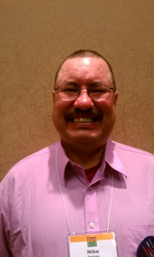
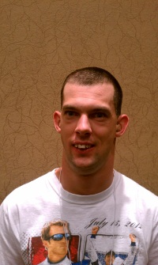
Personal fundraising presentations
Special presentations were made by David, Taylor Jr. and Mike Grengs on fundraising.

Business plan
Committees asked to continue to work on goals and objectives

Budget Review & Finance Report
Nancy presented review of revenues for grants. (Refer to spreadsheet)

Ryan introduced Darrell Burton joining the finance team as SABE Finance Coordinator. Darrell presented the 2013-3014 analysis of the budget. He recommended that SABE consider making SABE account electronic.

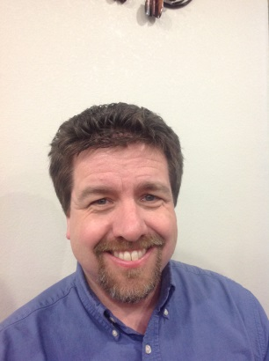
Essie gave a review of membership. There is concern over what SABE participants get from joining the national group. Leanne did a comparison of other organization memberships. Sponsorship and Levels need evaluating: Platimum, Gold, Silver, and Bronze
Levels need to be sorted out and defined.

Amira asked if there is a way to measure those who are members in each state, and is the rate per state the same or different.

Mike shared his concerns regarding corporations sponsoring money to attend SABE meetings. Darrell clarified that corporations can sponsor and this could be done.

Bryan shared with the group about the email address. Create the master data base. Send to Glenda’s email address, ghsingletary@fcdsn.org

Essie explained about the face of SABE and why the need to have presence in Washington. SABE may want to consider the title, Public Awareness Liason, for person identified to work in Washington. The person is to be paid $25/hour. This position will be advertised.

Need to have someone dedicated to fundraising. The finance committee thought that $6,000 is enough to get started. Bryan shared SABE has to take a stand to get the position. Our first step is to market what we need and why. Fundraiser does not have to be in Washington DC. This position can be advertised for $3,000 for Fundraiser position, and $3,000 to Public Awareness Liason position.

A motion made to accept the finance committee report for 2013-14 by Eric Treat. Clint Perrin seconded. Unamously the motion was carried.

Break 10: 50 am Reconvene 11:00 am

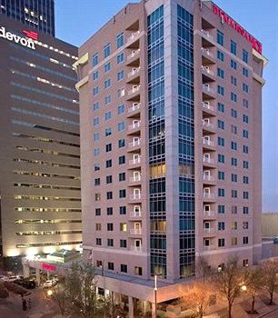National Conference update by Nancy Ward
The postcard, website and announcement will go out by end of January 2014.
The conference is scheduled for Oct. 9-12, 2014
Lance explained that (Oklahoma) OK has not been hooking up with SABE planning conference committee meeting. OK needs to work more with SABE because meetings are being scheduled around OK. The meeting is every first Wednesday.
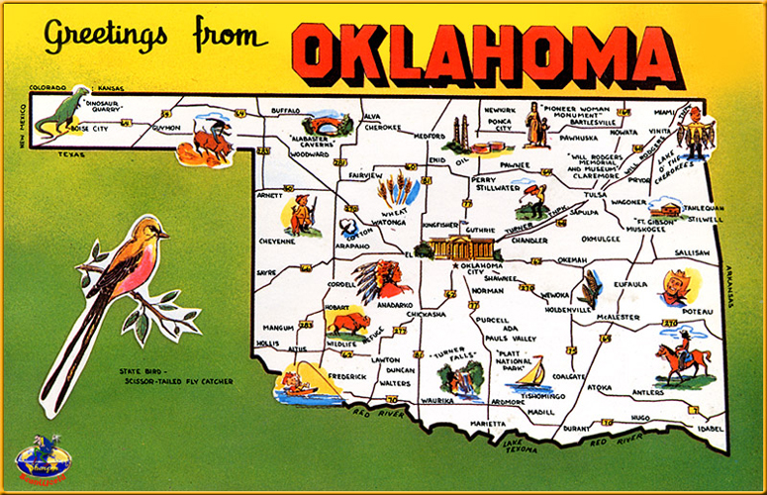
OK wants to come clean with the membershipon, needs and wants for SABE. OK is trying to get SABE involved.

Registration is $385 covers meals, t-shirt, and registration. It will be discussed at the next conference call about increase fee to $400 to add SABE membership. It is $38/meal for each participate or $275 (real cost meals). Registration increases to $435 after August 15. Onsite registration is $570.

Personal Care Assistant, supports, or staff registration will be $310.

18 board member or executive committee registration, $275, maybe waived for current board members. SABE members will have to pay $15 membership fee.

Conference activities or excursions may include museum, zoo, and cowboy hall of fame. OK feels like they are on schedule.

Membership: Existing membership is cards and pins. Proposal was received through verbal commitment from a former SABE advisor. The advisor indicated shared with Oklahoma that they did not have to guarantee membership in the registration fee of $385. However, Oklahoma was given permission to put the information about membership on the application. Essie pointed that the membership is more important to SABE than anything. Leanne suggested we make registration to $400 to include membership. Vicki presented concern over the cost. Judy mentioned that the bylaws say one has to be a member of SABE to vote. Lance indicated Oklahoma is trying to validate membership. We are moving to look at the bylaws to make sure that we are following bylaws. Lance suggested registration go to $400 per participant. This will need to be voted on by steering committee. Oklahoma did not realize that membership makes it possible for people to vote. Bernard questioned if the attendant wants to become a member of SABE then an additional $15 will be added to registration. There are some options in place to work with voting.

At this time Bryan then placed David, Jr. and Amira, to support SABE for donations. If you are willing to talk the talk then walk the talk, make a sub-committee for fundraising. Credit cards and P.O are being accepted for the conference. E-committee has seen the hotel, the Renaissance. The Sheraton is very near as well as another hotel for overflow.

Lunch Break12:00 Return 1:15 pm

Bryan asked for get well and thank you notes to be signed and sent to: Hannah, Marc the former accountant, and John Britton.

Committee Reports:

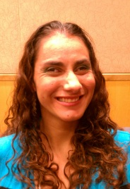
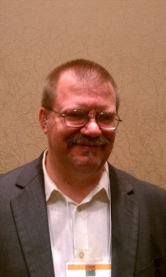
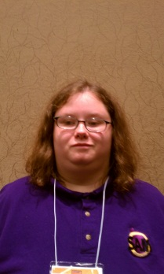
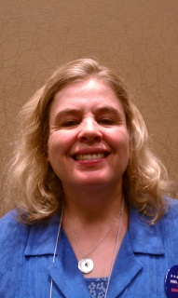
Public Relations –Newsletter needs to be sent electronically or bring on UBS drive. It will make it easier for the drop box. The fall newsletter will be resent because of email glitches. Anybody can donate to SABE notice will be a permanent posting. Committee asked for corrections to be forwarded before newsletter is sent out. March 16, 2014 is deadline for the next newsletter. If articles are not submitted in time, they can go in next edition. State contacts will be updated as well as contacts with Washington, DC. Committee asked advisors to up date the national list of contacts. Information about the national conference is asked to be covered in the newsletter. Some articles are being edited to clarification to information being submitted. Editing will be done for articles submitted. Motion made by Jason to accept PR report, second by Eric T. Motion passed.

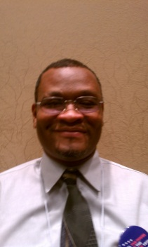
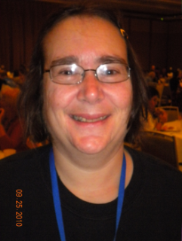
Grassroots- A webinars is being put together for Feb 25, 2014 2:00 pm - 3:30 pm eastern. Committee shared a video that they created during their meeting on the terrific conversation shared by members speaking out on closing institutions. Clint, Chaqueta, George, Anne, and Darrin expressed their opinions on the video. Topper captured the speaking moments with great pride. There are some states that have positive vs. negative experiences regarding institutions. The video was awesome. Everybody was able to give their input. Topper shared that capturing this kind of talking moments can be done easily and can generate training tools.

Close the Doors
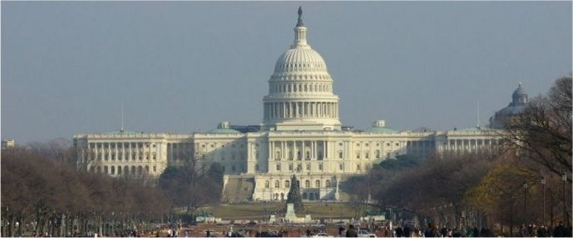
Close the door and Legislative Committee Report
Committee members:
Tia, Eric M., Eric T., Mike G., Bill, Juliana
- Stories about Closures
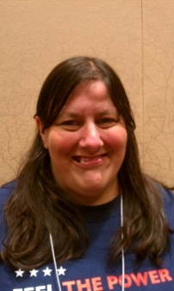
Eric M. will talk to Ruthie about lawsuit
Bill will talk to Kansas, Mike G. will talk to South Dakota, and Eric T. will talk to Arkansas about institution closures and send to Max to put in newsletter

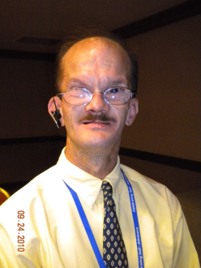
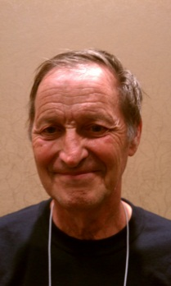
- Tia will request funds for Close the Doors and Legislation committee letter from Finance committee.
Product: CRPD t-shirts
SABE and CRPD logos
Budget
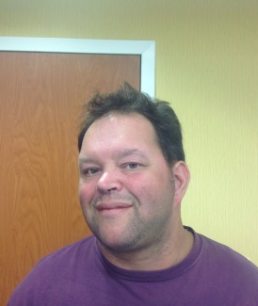
Cost of making shirts
$30-$60 set up fee
Purchase 200 shirts for $8.50 = $1,700.00
Total= $1,760.00
Income from shirts
Sell 150 shirts at Disability Policy Seminar $20 = $3,000.00
Give SABE board members 50 shirts
Profit = $1,240.00
- Next Close the Doors and Legislation committee call will be January 30 at 6pm CST, 7pm EST
Action:
Get approval from board members and Request funds from finance committee to purchase t-shirts

Tia and Eric Treat presenting: Talking to Tennesse about recent lawsuit on closing institutions. Other stories will be seeked from Arkansas, Kansas. Committee plans to do t-shirts to support CRPD and also wear and sell shirts at the Policy Summit in DC for April 6-9, 2014. Presented the cost of t-shirts. Could possibly make 1,240.00. Treasurer, Duncanwood has been made aware. Committee is waiting on permission from the policy summit. UIC scholarship is another way to support self-advocacy. 3ELove is a way to support different disability groups. The wesite was displayed for view to members. SABE asked to wear the t-shirts. Advocates in Action in RI to Close the doors video from RI to be discussed. Clint motioned to accept the close the doors report and Bill seconded.

Max asked for follow up with SABE’s decision for support on the
Advocates for Action RI video at Ladd School was shown to Board members. Website is www.indiegogo.comprojects/best-judgement-ladd-school-lessons. A major discussion on whether to give 500 or 5000. Clint suggested having 800 eyes looking at the movie. Each person goes back to each state to get boards and other resources to support, spread the word. Lots of discussion was entertained with ideas. The movie will be brought up at the next national conference steering meeting. Bryan suggested SABE will give 500 immediately and give the other money once shirts are sold. When the money is sent to Advocate for Change in RI, a nice letter of support should be forwarded. A motion by Tia made to support for 500 and when other money is made from the profit of the t-shirt be given to Advocate for Change in RI. Eric Tweet seconded. Motion passed.

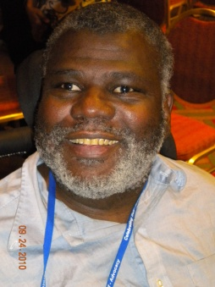
Policy – the committee will have the marriage penalty room at the national conference.
Grassroots will share the flyer on marriage penalty for distribution. Bernard will check with steering committee for request. Will also share flyer at the Policy Summit in DC.
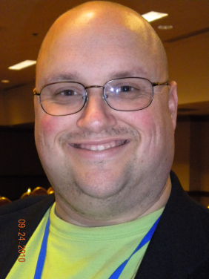
The committee will submit information on President’s email through David.

Bryon reviewed the pros and cons on tips for go to meeting/webinars. A broad discussion was done by the members on evaluating face to face meetings or webinars/go to meeting concept. (See attached handout) There may have to be 4 face to face through by laws. The by laws will allow us to amend to less meetings but have to let the IRS know. No determination made.

Siblings Network
One of the Items we talked about was the fact that we had elections and Pat carver was elected board chair and Barb Saproins was elected vice chair we also talked about some exiting things with sibling leadership network and we are a promotional partner at the disability policy seminar and also we talked about presenting at the SABE conference

Meeting Adjourned and next meeting will be in Washington, DC, April-10-12, 2014.

