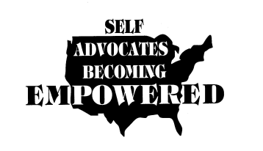
Self Advocates Becoming Empowered
Board Meeting

Hampton Inn
8728 Colesville Road
Silver Springs, Maryland 20910

Friday, January 30, 2015 – Day 1

Record of Attendance:
President, Tia Nelis, (Illinois)
V. President, Kathy Enfield, (Missouri)
Secretary, Chaqueta Stuckey, (South Carolina)
Treasurer, Ryan Duncanwood, (California)
Sergeant at Arms, Darren Morris, (Alabama)

Vicki Wray (Colorado)
Carrie Varner (Minnesota)
Chad Sinanian (Connecticut)
John Britton (Arizona)
Joan Schiele (North Dakota)
Gary Rubin (New Jersey)
Amira Rasheed (New Mexico)
Max Barrows (Vermont)

James Meadours (Texas)
Jason Billehus (Montana)
Teresa Coleman (Georgia)
David Taylor, Jr (North Carolina)
Eric McVay (Maine)
Ann Frecht (Massachusetts)

Note: Every region represented!

Allys and Support:
Leanne, Juliana, Glenda, Vicki, Topper, Richard, Darrin, Teresa, Shonda, Yemi, Darrell

Welcome and Introductions
Meeting was started with a “getting to know you” ice breaker. Tell (2) truths and (1) lie. The board members decide which the lie is. This activity was done to get everyone relaxed and comfortable with each other.
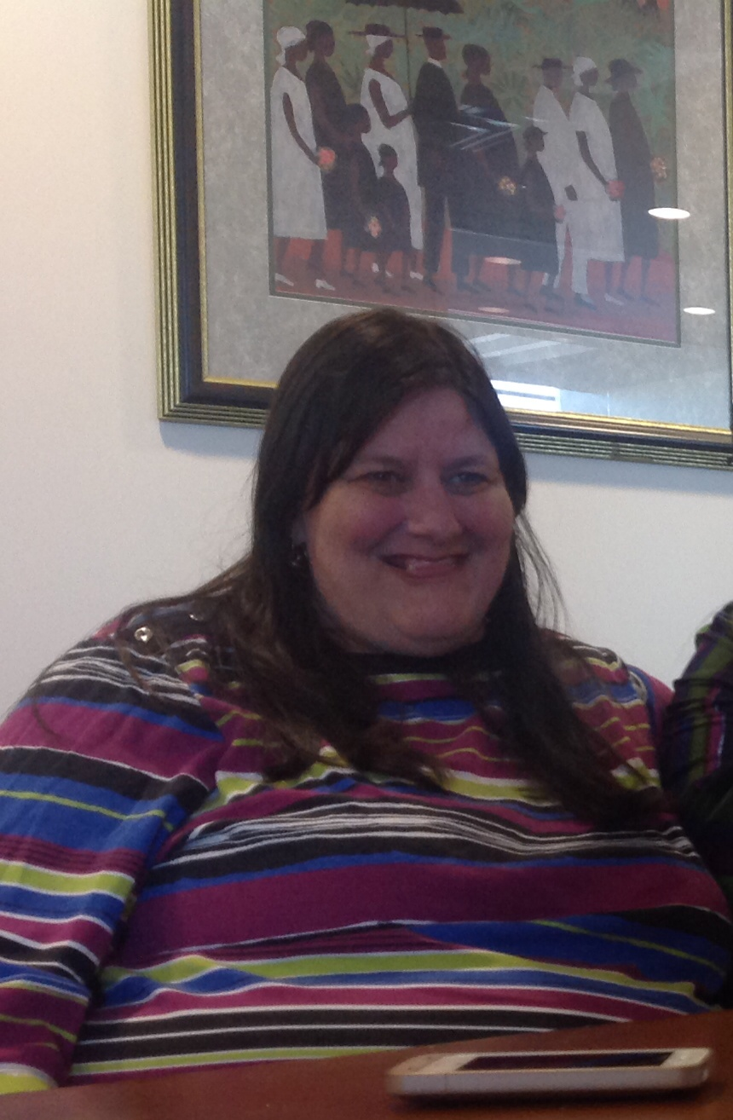
Meeting was called to order by President, Tia Nelis

President’s Report
Members informed of the voting survey (Project VOTE) and encouraged to get (2) other people from your state to complete. The survey is on SABE website under project vote. This survey is to bring awareness to voting.

All members were given the Board of Directors directory for 2015. Members were advised to make sure the information was correct. Those members who would like to receive txt messaging through their cell phone will need to inform Leanne.

Tia reviewed the agenda, introducing flash drives in the place of the bulky manuals. Committees were introduced and members encouraged to think about what committees they are interested in. The assignments for each of the committees will come later in the meeting agenda.

Policy Seminar
SABE paying only for registration! Food and hotel is on your own. Members informed that the Hampton Inn can be an option for accommodations based on expenses.

SABE Board Meetings and upcoming Conference dates:
April 8-12, SABE Board Meeting, Silver Spring, MD
April 14 – 15, Policy Seminar: Washington, DC
July 17-19, SABE Board Meeting, Chicago (Disability Pride Parade and an updated video of SABE will be filmed and featured.)
Oct. 9-10, SABE Board Meeting, Georgia

Tia expressed the importance of having funds to be able to attend SABE board meetings. The rules are in place to make sure that everyone is financially secured to participate. It was made clear that if people cannot afford to attend meetings to be on the Board, they needed to rethink their committment. Members having problems were encouraged to go back to their perspective states and clarify. At this time, Chad he gave up his position as representative for region 8 and became an alternate representative. The Board thanked Chad for his honesty in realizing financial limitations for attendance at Board meetings.

Committees Reviewed and explained the role of each committee. Each committee will select a chairperson.

A description of each committee and members:
Finance will manage the budget and ensure funds are secure.
Chairperson Ryan
Joan, Ryan, Amira, Vicki T.

Public Relations will produce all newsletters, management of website and other related news to publish SABE
Chairperson Carrie,
Chaqueta, John, Eric T., Juliana

Legislature will look at the issues that are important and relate to bills and acts that are in action
Chairperson - James
Eric M, Chad, Max, James, Cathy, Topper

Policy will look at procedures and policies that provide rules and regulations.
Chairperson - Bernard
Gary, Vicki W., Sam, Leanne

Grassroots will look at the development of self advocate groups and their communities
Chairperson - Darren
David, Anne, Jason, Teresa C., Glenda

All members encouraged to provide regional reports and submit consistently to the PR committee. Take pictures to support your articles. Reach out to your regions with calls and promote regional meetings. Let people know what is going on with SABE. Refer people to the SABE website and keep people informed as to what SABE is doing.

Steve Taylor was remembered by some veteran SABE members. He was one of the pioneers of Self Advocacy Movement.

Meeting adjourned with lunch own your own and committee meetings starting back at 1:45 pm at various locations.

Saturday, January 31, 2015 – Day 2

Meeting opening with group picture as some members are departing early.

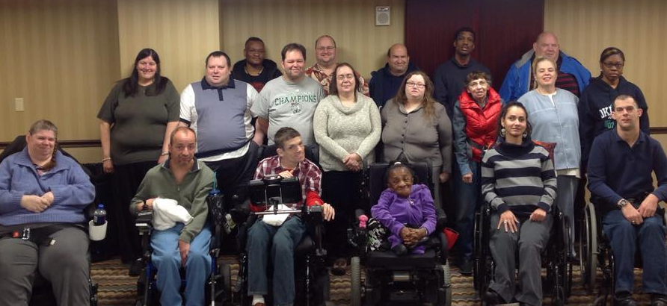

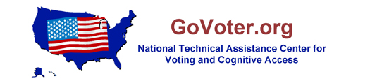
Project Vote
Things are very busy. Project VOTE and volunteers helped SABE with membership process at national conference. 206 people voted and top priorty community living, employment, marriage penalty.etc

The grassroots campaign surveys on voting and assessibility are kicked off and states are asked to get others from states to get them filled out. The goal is to complete 500 surveys. You can find these surveys under SABEUSA website. It was shared that people should be more aggressive to make voices be heard by going out to vote.

Project vote distance training will be introduced to (4) states. This is a partnership with P & A and a self-advocacy group. These two groups will need to work together. Members encouraged to share with SABE what they are doing with voting and it can be shared on the SABE website. Send your emails to Teresa. Project Vote has a Facebook page, NTAC. https://www.facebook.com/govoter

They worked with AIDD and NDRN and helped these groups work on webinars on voting education. The secretary of state office is in a major training project on voting. There will a lot of exciting things to come.
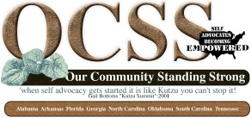

OCSS (National Technical Assistance Grant)
States have produced 24 videobloggs and worked with project vote on technology. OCSS is working with states on state plan. OCSS is up and running on SABE website. Advisory Board has met (3) times. The next face to face meeting is on March 19-21 in Myrtle Beach, SC. The evaluations for surveys are completed. We are focusing on technology. Working with partners has been successful for the most part. Needs Assessment and webinar topics identified for 2015: How do we keep our efforts going (Sustainability), How to include new members, Partnership among communities and Leadership. We are working on encouraging the other states that are not participating by offering a stipend for completing surveys. The Long Road Home Campaign Project and ADA events will be areas of concentration for activities.

Everyone is encouraged to attend OCSS webinars which are scheduled for:
2/18/15 – Leadership skills
4/23/15 - Strategies for Effective Team
6/18/15 – Strategies for membership Recruitment
7/16/15 – Steps in Organizing around an Issue
8/20/15 – Partnerships Outside of the Disability Community

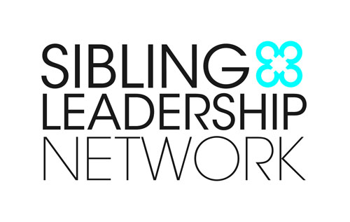
All of the Video blogs are on the SABE website. The states participating in OCSS are: NC, TN, OK, FL, AL, SC, AR, and GA. The southwest is working with some of the OCSS tools to get a jump start on their grant efforts.

Siblings Leadership Network
The group is working on plans for a conference in Louisville, KY which will take place on May 30-31, 2015. Eric M. participates on program committee. The sibling’s survey will evaluate how siblings work together and support each other, sharing stories to learn from each other. They will be working with the siblings networks in all areas. The survey is open to self advocates and parents. The goal is to have survey completed by the end of March. SLN just elected new national officers.

New Projects Coming:
Employment Project Technical Assistance
A questionnaire will be provided to SABE members to determine who the best fit to work on project. SABE will receive $10,000.00 over a 3 year period of time. Eric M., Max, James, Jason, John, and Amira are most interested in this project. Those selected will need to be able to be available and flexible to meet the many calls that will be scheduled. They will also be asked to participate in presenting at various conferences. SABE will determine how money is to be allocated. The executive committee will discuss to make determinations.

Diversity Project
A leadership academy is starting. SABE will work with this project for 3 years. There is a scholarship for attendance in this academy. This grant is about giving people with color an opportunity. SABE may want to evaluate representative to fit the diversity project. The executive committee will discuss to make project representative assignment.


Flash Drives were given out. The flash drive is inclusive of the Travel policy, complete manual, and contact list update. Members will need to upload flash drives as needed. Please bring your flash drive to the next meeting.


Committee Reports
Finance
The Budget Report was provided by the Ryan. Budget goes from July 1- June 30. Revenues are $240,000. Budget is $204,000 for expenses. It is anticipated that there is around $36,000 of funds uncommitted. Money is coming in. In the bank now is around $74,000. However, expenses are being paid out to date. There are regular expenses being paid out every month.

SABE is dependent on grants. Fundraising opportunities were also mentioned to do membership drives in starts right after a national conference. Membership will also be apart of the registration fee.

It was confirmed that SABE is still recruiting the Fundraiser position. Person needs to be from DC area because SABE will not pay for living expenses. SABE is still waiting on the self advocates from DC to submit their information.

James moved to accept the 2015 budget and report.
The motion was made to accept the finance committee report for 2014-15. James Medours motioned to accept. Eric McVay seconded. Unamously the motion carried.
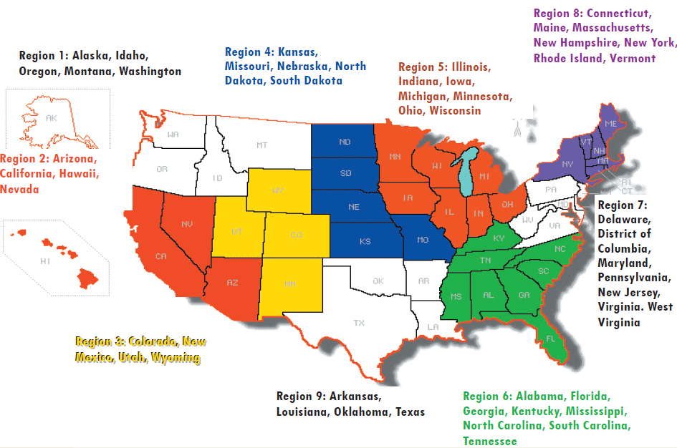
Grassroots
Anne reported on the importance of developing self-advocacy groups and the strategy for this committee is to identify areas and states that SABE has no contact. The committee will use the SABE updated video being produced to help them with education these areas and the community.

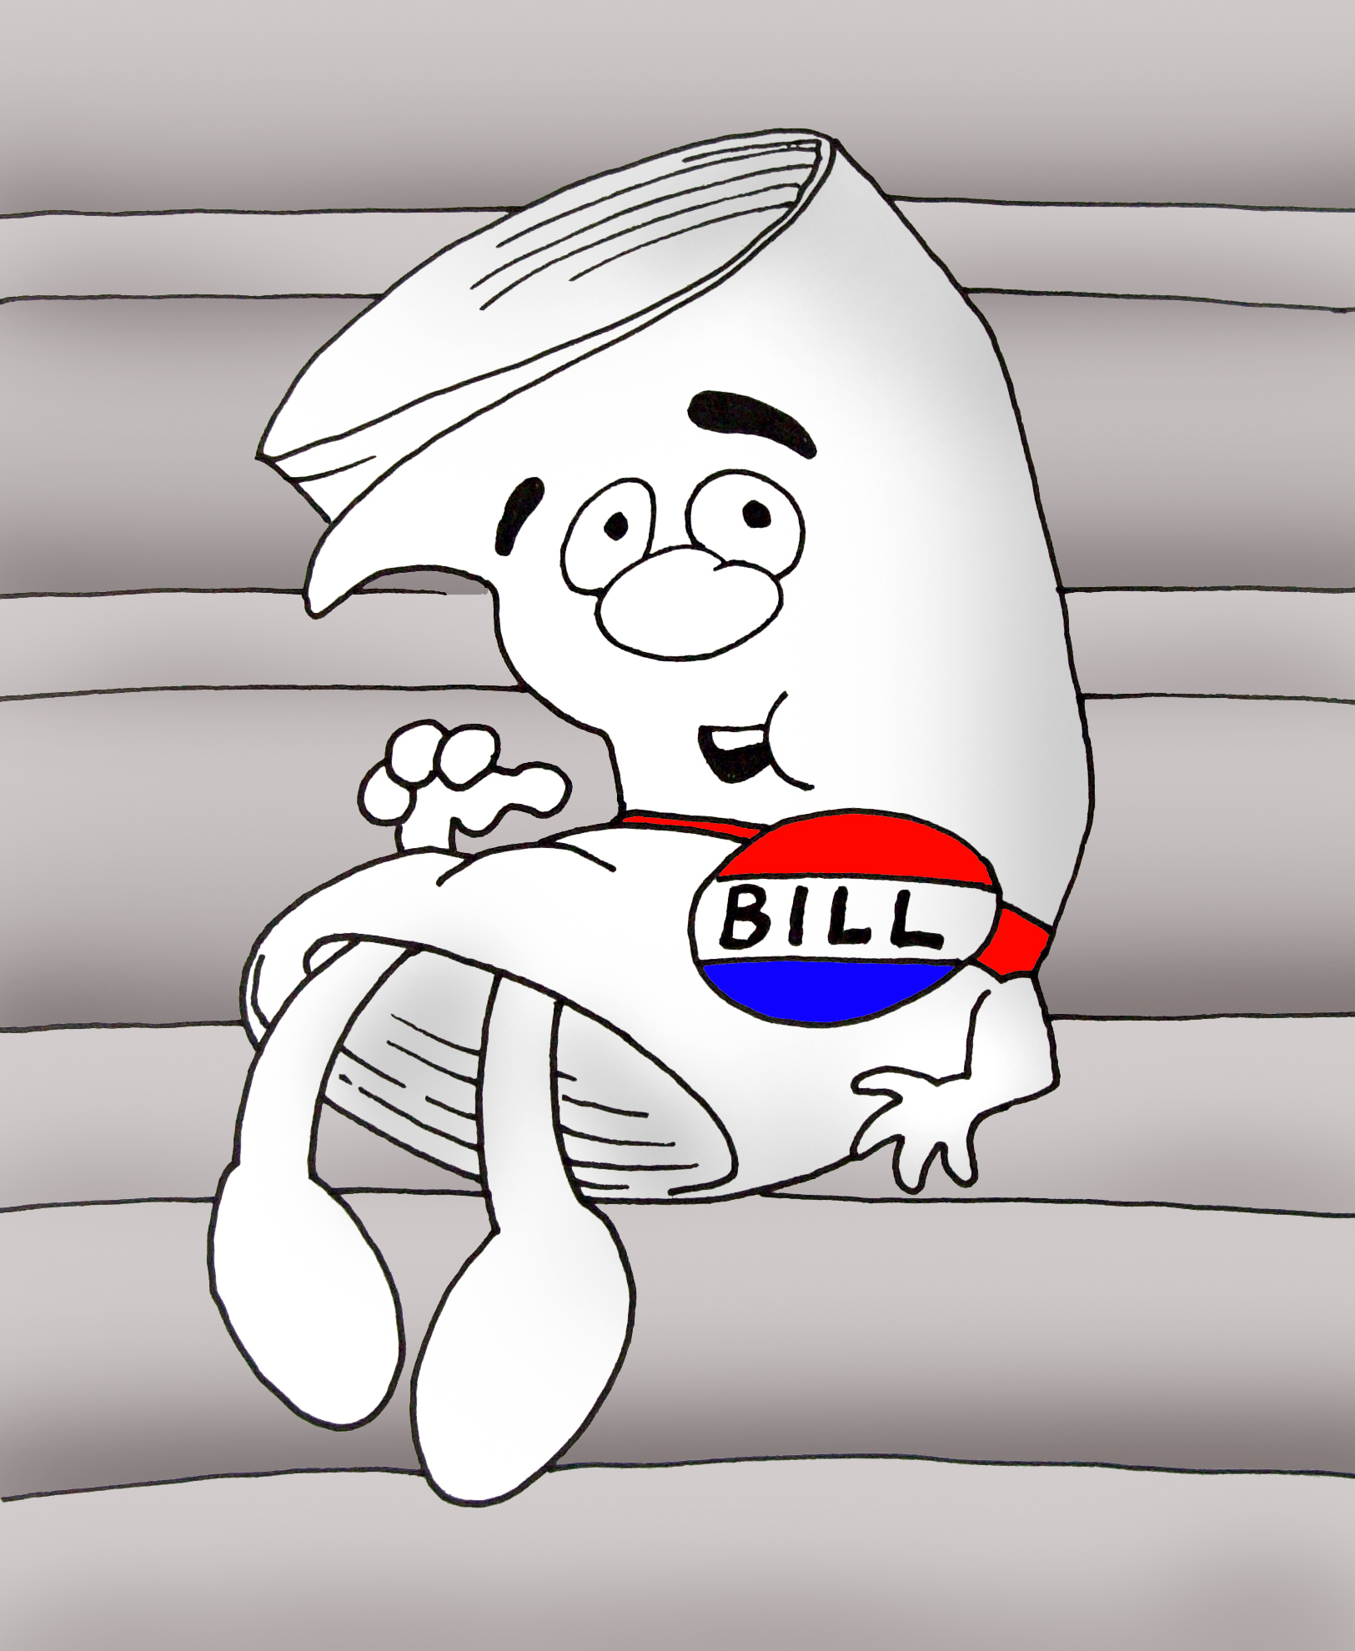
The struggle of self-advocates understanding self-advocacy is also a concern especially in getting the youth in the movement.

Legislative
James reported that they will work on bills to support issues. Transportation and working with police on educating to self advocates.

Legislative Committee January 30, 2015
First task was to create a Job Description for Chair. Below is what we agreed on. Then we discussed who was interested in being chair. James and Cathy volunteered. After more discussion the committee decided to have co-chairs.
James | Be willing to work with states on what they are working on
Cathy | Run the meetings
James | Do the reports for SABE or gets support to do the reports
James | Set monthly meetings
James | Email and call all members to remind them when the meetings are
Cathy | Keeping communication going between us and make sure everybody knows what is going on
Cathy | During meetings making sure we are on track
Cathy | Point of contact – for legislative information
Cathy/James | Together making the agenda
Priorities:
- Working on bills to phase out sub-minimal wage; institutions and marriage penalty. Make sure the states are held accountable.
- To get better at paying attention to what is going on in the legislature (nationally and state) if it is important to get the word out.
- Consider legislation in states or national for education of police officers (criminal justice system) sensitivity training on interacting with people with developmental disabilities.

Our next date for meetings
First Feb 3rd 5:00 to 6:00 (Max, Eric McVay, Chad) Tuesday 4:00 to 5:00 (James and Cathy, Eric Treat)

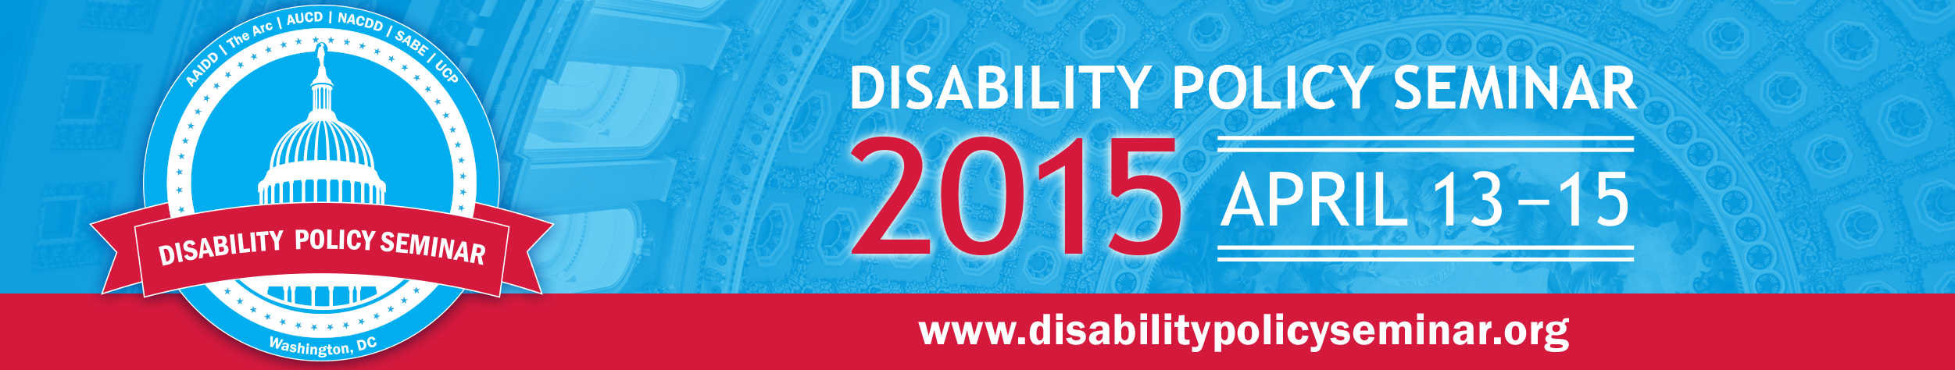
Disability Advocacy Seminar will reflect important issues.

Disability Policy Seminar
SABE is organizing 2 sessions for DPS. SABE is in charge of organizing Self-advocacy breakfast at Disability Policy Seminar. We decided to hear from our members. President Nelis will facilitate each state give one example of their most exciting legislative or policy advocacy work they have done in 2014/2015.

Agenda Planning
On Saturday January 31, 2015 James and Cathy will meet at 8:30 to plan agenda for February 4th conference call.

PR
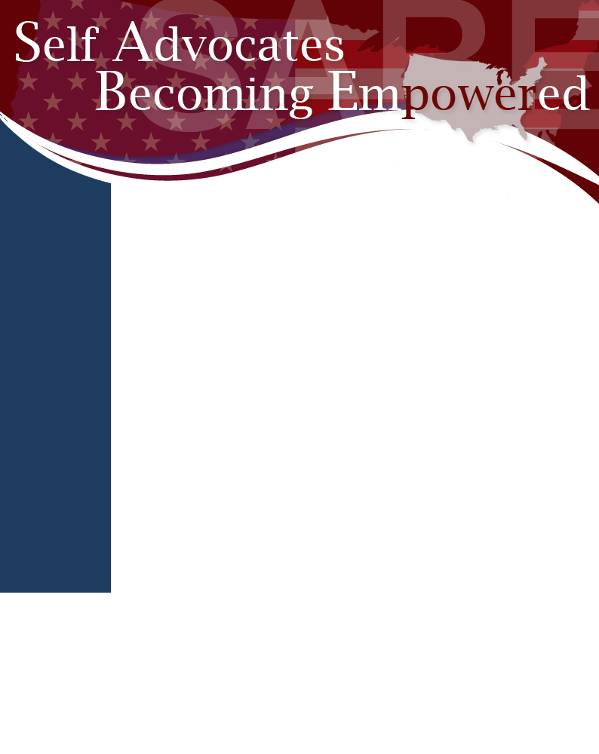
Team Carrie encouraged everyone to work with forwarding regional reports. They encouraged articles to be forwarded for the production of newsletters.

They will work on keeping the website current and full of SABE news.

Policy
Team Bernard shared that they would be looking at what is in place with existing policies then move forward with updating those that need editing or developed.

Tia indicated that the next meeting is before the Policy Seminar. Members encouraged to view Liz’s videos on the ABLE ACT. Tia attended a meeting on the hill. There is a bill out there that parties are communicating on people getting an education. The parties are not working together on people being able to get their diplomas, GED. Getting an education is very important to SABE.

Any groups or persons requesting to speak to SABE will go through a procedure in order to come in at board meetings.

CRPD is dead! The treaty was not passed due to misinformation. Senator Harkin really worked hard but was totally disrespected. It is hopefully that this issue will re surface in time. SABE is aware of who was for and against the treaty. Topper suggested that Ari be tapped to discuss SSDI.

New and Old board members welcomed again for a new year of working together in the movement of self-advocacy. James shared that SABE has come a long way and he is excited about being back. Eric is excited to represent on the Board after a representative change happened during this meeting.

Tia reminded everyone to share information on regional information with states. ADA 25th Anniversary is coming up and if there is information, Tia will inform. The ADA bus is going around to all of the states.

Meeting adjouned and next meeting will be in Silver Springs, MD., April 10-11, 2015.

