January 18, 2019
SABE Board Meeting
Phoenix, Arizona

Executive Officers Present:
Bernard Baker President (Georgia)
Vickie Wray V. President (Colorado)
Eric McVay Secretary (Maine)
Darrin Morris Treasurer (Arkansas)
David Taylor, Jr. Sgt at Arms (North Carolina)

Members Present:
Diana Mairose (Ohio)
Melody Cooper (Indiana)
Roger Crome (Missouri)
Anne Fracht (Mass)
Gary Rubin (New Jersey)
Temp, Ryan Duncanwood (California)
Temp, Jason Billenhaus (Montana)

Advisors, Allies and Supports: Heidi Haines, Glenda Hyman, Julianna Hurera, Essie Pederson, LaShonda Hinds, Teresa Moore, Bill Lucero, Charlotte Glover, Mike Smith, Wendy Crome, Amanda Circle

Bernard welcomed all members.


Allison Hall joined meeting from UMass to discuss the new grant that will develop an app for Employment Specialist (Consultants) to use with smart phones. This data will help analyze employment opportunities. The app development will have a screen reader to make sure the app is assessible. Jerry volunteered to offer his support with screen writing. Members also suggested LEND as a funder to support the grant. A video was shared to see what the employment consultant would see when using the app. It summarized the day of interaction on employment activity. The app shared the kind of data the consultant would be gathering and entering from the survey. There will be other platforms outside of smart phones as alternatives. In addition, there will be several opportunities for people to try out the app. Members shared that they would like an app with pictures and voice active. As for as the self advocacy employment app, people would like for the app to help with keeping in better communication for resources, manage independently in-home clues (system of reminders), and should be universal to everyone. Eric also questioned the security of the app. Mrs. Hall shared that Information would be kept in a common place and privacy would be priority. David suggested the capability of microenterprise boards. The website shared for app is: thinkwork.org. A motion was made from Eric McVay and Diana Miarose seconded the motion for SABE to provide a support letter regarding the grant and participation of the employment grant.


Bernard and Tia presented the United Nations presentation. It would give SABE a great benefit to use resources worldwide. There would be conferences, international website, and interaction with other countries on behalf of what others do to support people with disabilities. It may lead to other opportunities for SABE. We will need to complete an application. It will not cost anything. It will help build SABE reputation and work with others on projects as well as working with to consult on something the UN maybe working on. There will be website login for members to see what others are working on. The UN could ask at times to have SABE members to talk on an issue (example… views on human rights). The members from SABE representing would have special badge to get into all UN events. Members will also have to get their passports in place. It is such a great opportunity to show an affiliation with UN. It takes a year for the application to be approved. Reports have to be submitted to UN. SABE will need to get started early for starting the application process. The UN may want to visit SABE. If we miss the application timeline, your application will be sent back. The application has to be submitted before June 1, 2019. The UN will identify an issue or matter around people with disabilities and SABE would consult the UN on a position for SABE. It would be a learning experience for SABE and UN to be in this partnership. SABE has history with working with other countries. However, this partnership would allow consistency with the world. The UN takes information that they get from their consultants. It will give the true picture of information being shared with the world. It will give another door to open for SABE. Roger Crome made the motion to accept and David Taylor, Jr. seconded with a third by Eric McVay for SABE to join in membership to the UN.
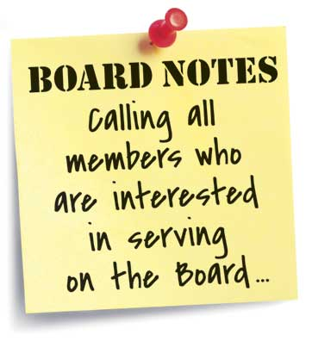
Board Applications were sent out through SABE website and list serves.

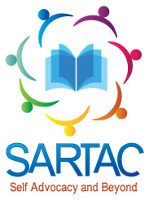
The application has been extended until Feb. 17, 2019. Bernard supports are LaShonda Hinds and Tia Nelis. Please copy them on any communication to Bernard. If you have people in your region interested, an application must be in place for consideration on board. People will still have to do the letter and financial documentation support. Plan two will be to go contact physically the region.

SARTAC (update and reports) by Teresa Moore (see attached)
A summary of new fellows was provided. Progress on the toolkits and technical assistance to states were also discussed. In support of the history of the movement Self Advocacy was discussed. Questions were asked of members to survey opinions. Members had an opportunity to give feedback to the following questions:
- Is there a disability culture?
- Do you identify with your disability?
- What does self advocacy mean?
- What is the self advocacy movement?
- Does the term “self advocate” mean anything to you?
- Do you identify as a self advocate?
- How do you think other people view you?
- Is the self advocate movement still alive?
- Are there things you still need to fight for?
- What were the goals of self advocacy movement?
- What are the goals of the self advocacy movement now?
- Does people with other types of disabilities accept people with intellectual and developmental disabilities?

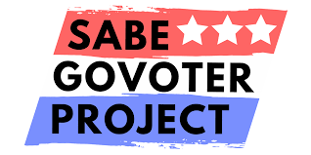

GO VOTER Report by Teresa Moore
Survey Progress
The top (3) states leading the surveys is: North Carolina (leading), Wisconsin, and Indiana. The question for SABE is should we extend survey process. The state that takes the surveys will get free registration for 2020 National Conference. To improve on survey results, SABE members need to follow up with their states. The surveys will close on Jan. 30, 2019. Distance training is moving forward and works very closely with P & A. Letters have been sent to states that have expressed interest. Lots of great discussions come out from the voting laws from each state. SABE is also able to learn from each other and talk about barriers each one face. If a state has participated before, one state will have an opportunity to refresh on input. Check out the website and see what this great training can do to support people. The website is constantly updated. GoVoter team went to the state of the Latino vote. The team learned the importance of being counted in the census. It is important to participate in the census. It is important to have proper language voting materials for people to vote. A new project is underway for a GoVoter Retreat, which will include states who have most recently completed the distance vote training. This will help expand relationships with resources. SABE GoVoter project is so excited about this new opportunity about to happen. A motion was made to approve the GoVoter report was made by Eric McVay and seconded by Gary Rubin.



The board went into a closed session to discuss Juliana’s contract.

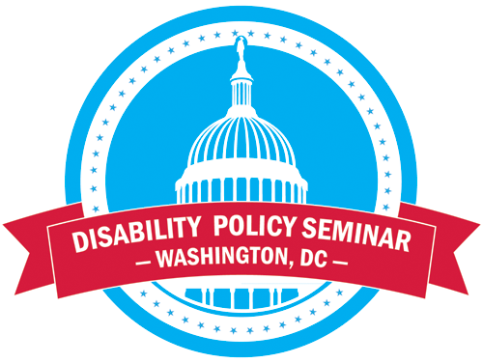

Disability Policy Seminar
Sponsorship in place for Darren Morris,
Needing support: Mel, Bernard, Diana, Roger, David, Eric
$255 registration for self advocate
$190 registration for support
There will be a self advocacy breakfast, but no assignments will be determined until members are identified for attendance.

Bernard instructed committees to gather for dinner or first thing in the morning for reports.

Members need to consider dates for Summer and Fall meeting.
State reports will be delayed until April 2019.
A review of the website was shared with members.

The board voted to have Bernard linked directly for business email. However, Bernard over ruled at this time until email is secured. Members have also asked about getting business cards for increasing communication. Members also appreciated and like the more assessible website. Members were encouraged to share SABE Facebook and post things that are happening.

Day 2- January 19, 2019

Finance Report by Darren Morris, via phone Vicki Turnage & Darrell Burton (see attachment)



Public Relations Report by Diana Mairose & Ryan Duncanwood, Juliana Huerena
Diana shared with SABE that Betty Williams passed. The Fall Newsletter was distributed among members. The spring newsletter is underway and is slated to be completed by March 21, 2019. A motion was made to approve the public relations report by Melody Cooper and seconded by David Taylor Jr.

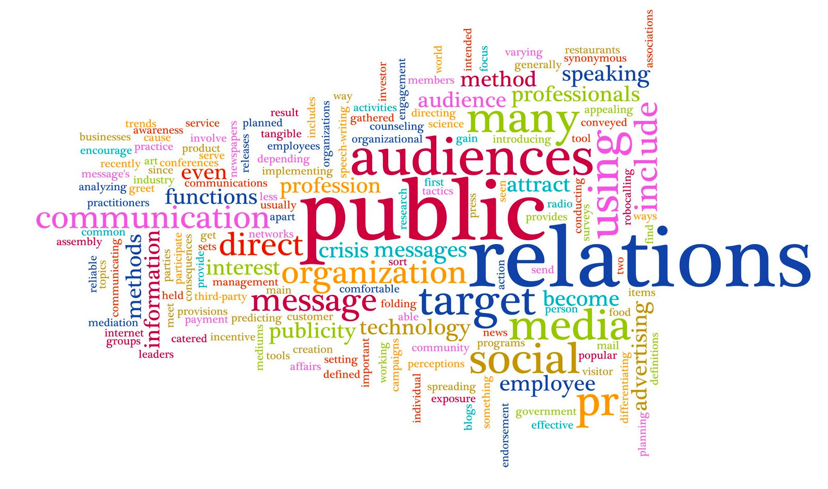

Legislative Report by Melody Cooper & Amanda Circle
A review of the Medicaid extension Act was shared. Healthcare coverage has been expanded in Maine. Update on snap benefits provided since the government shutdown is currently in place. A motion was made by Diana Mairose and seconded by Roger Crome.

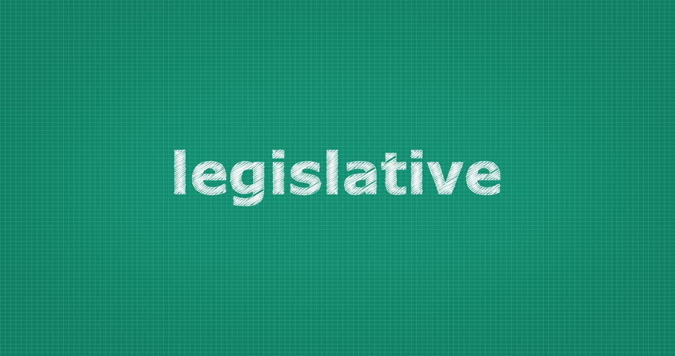

Policy and Bylaws by Bernard Baker, Vicki Wray, Eric McVay & Heidi Haines
Two main things are: the application process is being resent out for recruitment of members and the draft bylaws modification were reviewed by the board, SABE will vote on the changes at the next (April/19) board meeting. A motion was made to accept the report by Gary Rubin and David Taylor, Jr.



Grassroots by David Taylor, Jr., Anne Fracht, Darren Morris & Glenda Hyman
The report centered on ADA being apart of our everyday lives. Members were reminded of making sure that businesses and environmental settings are accessible as well as safe areas. SABE was also asked to consider supporting David’s interest on becoming a certified ADA Coordinator. He is starting a movement in North Carolina and reaching out to City Council and Kiwanis Club for support.
A motion was made to accept the report with amendments by Diana Mairose and seconded by Eric McVay.
Membership fees were also shared for updating fees. A motion was made to accept with amendments bases on bylaws update pending.



Close the Doors by Roger Crome, Gary Rubin, Jason Billehus, and Charlotte Glover
Primary goal is to get every individual who is in an institution in the community. They developed steps to reach goal. First step- find out what states have people in institutions vs. states without institutions, then look at research on what happens when the transition happens. At the next meeting a list will be established for review. A motion was made by Vicki Wray and seconded by David Taylor, Jr.

Bernard clarified that the ADA states, “People have the right to live in the community.” Close the Doors committee will be asked to look at rehab centers and other settings. It is not fair when people get put in institutions. There are other ways to help people live in the community. SABE has done research that says people live better lives.

Roger expressed the importance of communicating openly. We need to look at what people need to be independently. We need to look at how to make supports a reality. You sometimes have to get emotions out of the way. We all have a passion. As SABE, we are going to get the work done.

Project Reports
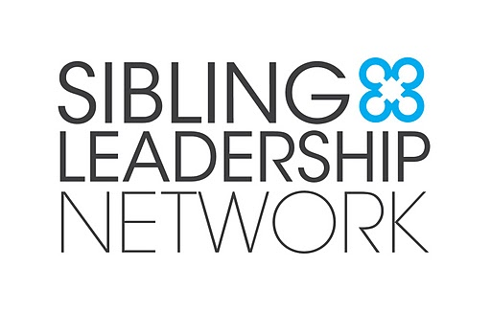

Sibling &Leadership (SLN) Network by Eric McVay
Eric recently presented at National Conference
SLN elected new officers
June 22-23, 2019 National Conference in St. Paul MN.
www.siblingleadership.org

RRTC Employment by Jason Billehus & Julianna Huerena
Update was provided on white papers and supported decision-making. SABE will work with UMass on employment app project. Allison Hall was a guest speaker for members to provide details.
A motion was made to accept the report by Darren Morris and seconded by Roger Crome.

SABE considerations and reminders
- Coleman Institute of Technology grant is up for consideration by SABE.
- Members reminded Part II Technology handbook is online.
- Georgetown University & Boston University Project (PCORI)– youth with mental health/disabilities research
- Georgetown University Leadership Academy (Wisdom Council) w/Dr. Vivian Jackson
- ARC National Advisory Council-deadline Feb. 15, 2019
- Self-Defense Training Class will be offered on June 6, 2019 at 8 pm at SABE meeting in Ohio

Upcoming meetings:
SABE Spring Board Meeting April 4-6, 2019 Silver Springs, MD
SABE Summer Board Meeting June 27-29, 2019 Atlanta, GA
SABE Fall Board Meeting October 3-5, 2019 Denver, CO
Meeting Adjourned

Self-Advocates Becoming Empowered Darrell Burton
Summary of finance meetings Juliana Huerena
September 14, 2018 Teresa Moore
Vicki Turnage
Darren Morris
LaShandra Hines
Bernard Baker
Tom Masseau
Meeting dates:
October 8
October 30
November 13
December 18
January 7

Activities completed and discussed

Audit
We shared the audit arrangements. The auditors are working on our audit in January 2019.

Bank Statements
We went over all the transactions for the September, October, November and December bank statements. We made sure they were recorded in the right place.

Phoenix meeting
We made plans for the meeting, to make sure we got everything done.

SAM registration
We discussed the registration process to apply for grants.

Bills to pay
We made sure all the bills were on the books.

Money coming in
We shared updates about the money coming to SABE.

Grants reports
We shared reports about all the grants, to make sure we don’t go over budget.
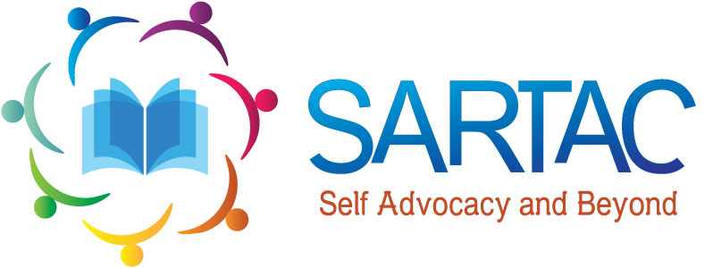

SARTAC Report:
- Advisory Committee met on January 13 and 14th.
- New Advisory Member from Hawaii.
  - Barthey Fong
- Year 2 Fellows are wrapping up their projects.
- Webinars will be scheduled in the Spring.
- We are reviewing 23 Fellowship applications.
- Civil Rights videos are projected to be available Spring along with 2018 National Conference videos.
- ACL-AIDD ask for SARTAC and SABE to discuss the term self advocate and its continuing use by the self advocacy movement
- New products to be released soon are Employment Policy Toolkit and Coalition Building.
- New tools continue to be added to SARTAC website. www.Selfadovacy.info
- GMSA continues to update self advocacy organizations contacts and host monthly teleconferences with states for Technical Assistance
- SARTAC and UMKC are supporting Region 6, 9 and States that participated in the Heartland Regional Center to host Regional meeting during the Spring and Summer.
- SARTAC Advisory Committee member will represent SARTC and SABE at the FLSANDS State Conference next week.
- Eric has been working with SARTAC and U of Minnesota on reviewing website and content of self advocacy on line.

